ComicCraft – AI Comic Story Creator powered by Gemini & Stable Diffusion
Project Design Phase
Solution Architecture
Date | 28/09/2026
Team ID | SWTID-2026-1512
Project Name | ComicCraft

Team Leader: LAKSHMIPRIYA M | Team Members: KAVIYA K, KIRTHANA, KOWSALYA M
Solution Architecture:
The solution architecture for ComicCraft focuses on building a modular, maintainable web application using Python and FastAPI. The application coordinates two AI capabilities — text generation with Google Gemini and image generation with Stable Diffusion — and turns their combined output into a preview page and a PDF.
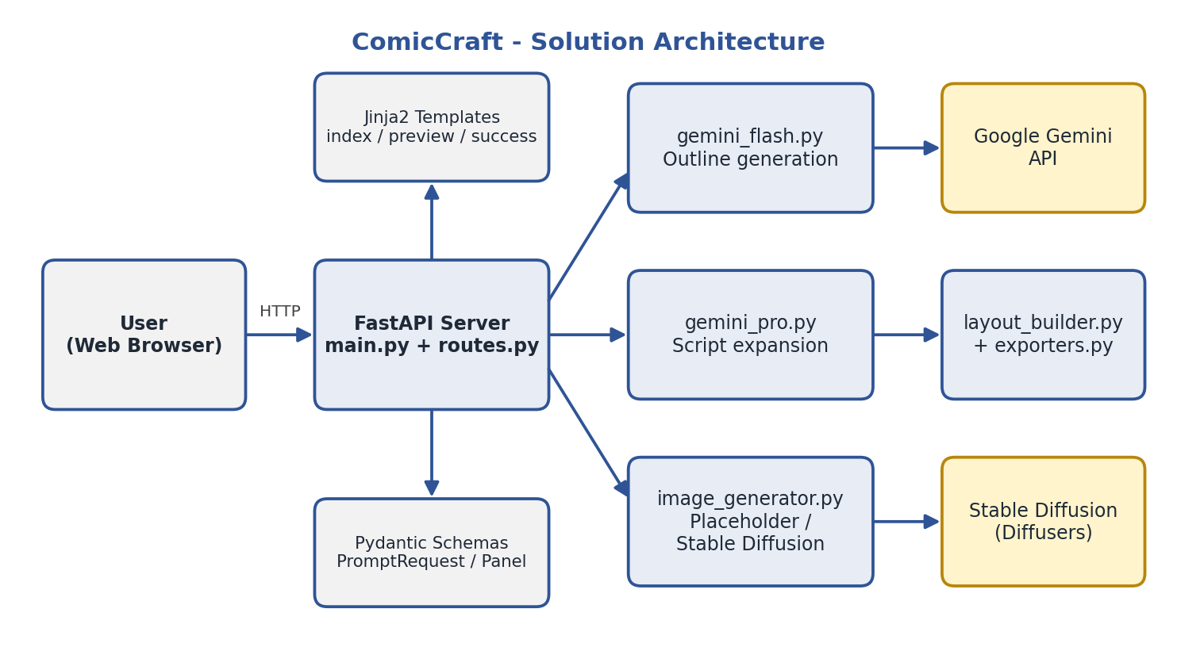
Figure 1: ComicCraft solution architecture
Goals of the Solution Architecture:
Identify the Best Tech Solution:
- Use FastAPI, Jinja2, Pydantic, Google Gemini, Stable Diffusion (Diffusers), Pillow, and FPDF2 to build an end-to-end AI comic creator.
Define Structure & Characteristics:
- Follow a service-oriented module structure with separate files for outline generation, script expansion, image generation, layout building, and export, keeping each responsibility isolated.
Outline Features & Development Phases:
- Plan development in phases: project setup and configuration, Gemini services, image generation, layout and PDF export, user interface, and testing.
Establish Specifications for Development & Delivery:
- Define request and response schemas with Pydantic, and keep secrets in environment variables.
- Provide an image-provider switch (placeholder or diffusers) so the same pipeline supports fast testing and real AI art.
- Return the result as an HTML preview for users and as JSON for developers.

